Nama :Iqbal Subekhan

NIM :18090006

Kelas : 5A

PRAKTIKUM 4

1. Source Code

Web.php =>application/controller

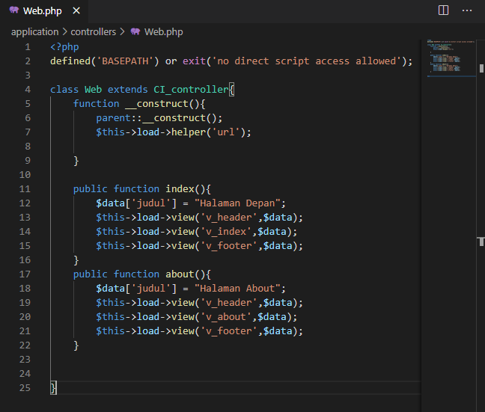

v_header.php =>application/view

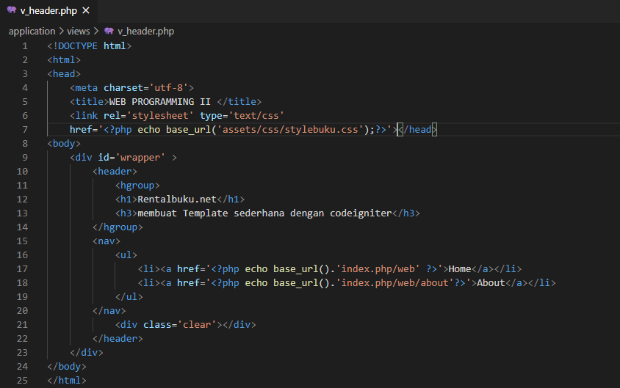

v_index.php =>application/view

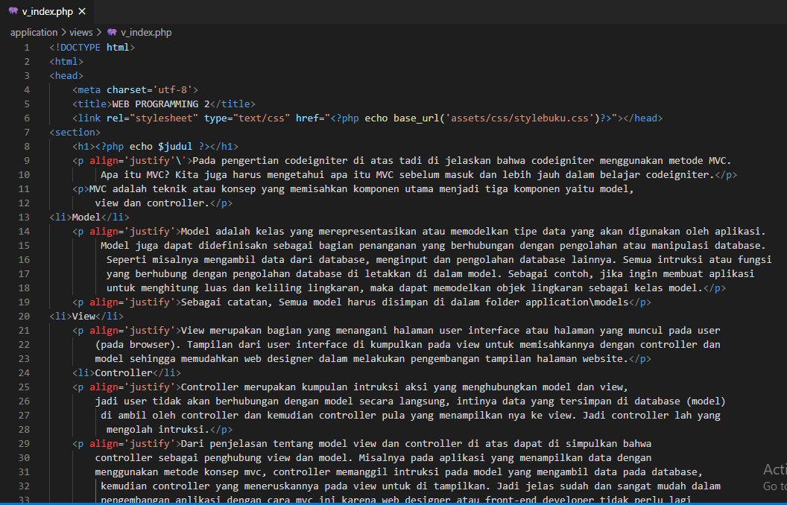

v_footer.php = >application/view

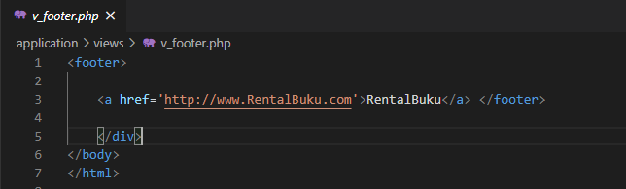

v_about.php =>application/view

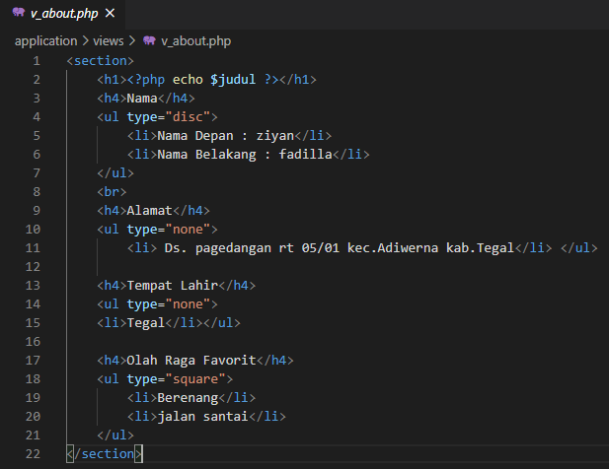

stylebuku.css => assets/css

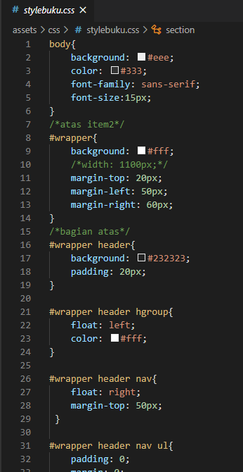

config.php =>application / config

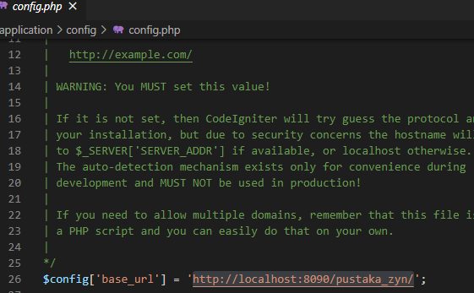

autoload.php =>application / config

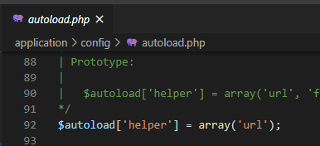

1. URL
2. <http://localhost/pustaka_Iqbal/index.php/web>
3. <http://localhost/pustaka_Iqbal/index.php/web/about>
4. Capture Hasil
5. Home

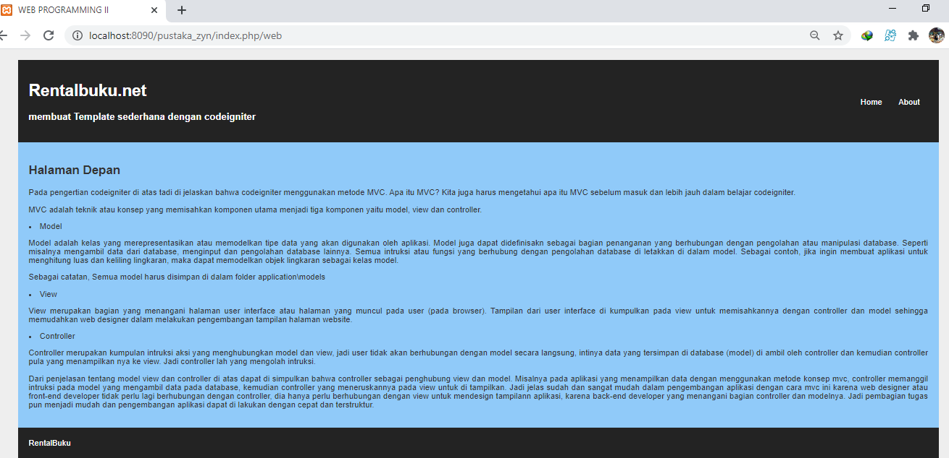

1. About

